Centralized infrastructure SOP for all OEM tasks

Preface :- this document helps anyone who is troubleshooting the lack of OEM alerts received pertains to both sites (production & DR)
Prepared by :- Oracle MS Infra Team (Solaianandh A)
Pre requisite :-

- OEM GUI access DR :- https://172.24.2.100/em
- OEM GUI access PROD:- https://172.20.4.106/em
- CLI access to OEM App servers if required to check the logs (OEM App servers in respective environment)
Based on the issue raised. The sections given below must be used.
Index :-
- Scenario 1 (OEM Agent down)
- Scenario 2 (how to check agent availability in GUI)
- Scenario 3 (How to check OEM has application targets added )
Scenario 1 :- (OEM Agent down)
This scenario is mainly for troubleshooting the OEM agent is reported down.
Sample alert :-
Agent down, unavailable
Default user with which OEM agent will be running on all Impact servers across both the sites will be “oemuser”
There is on default path, so better you can do process search with oemuser for the path where to check the agent status
Eg:-
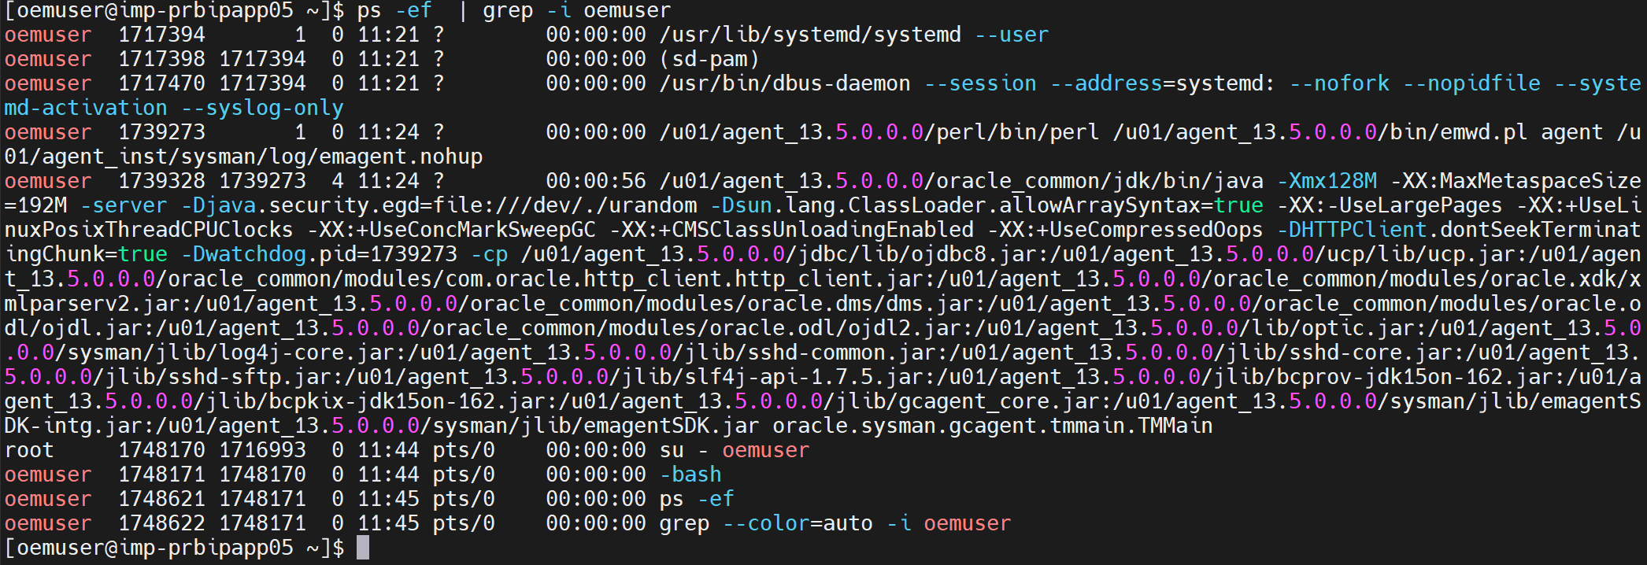
In this case /u01/agent_13.5.0.0.0/bin
Command to check the agent status is “ ./emctl status agent ”
Eg:-
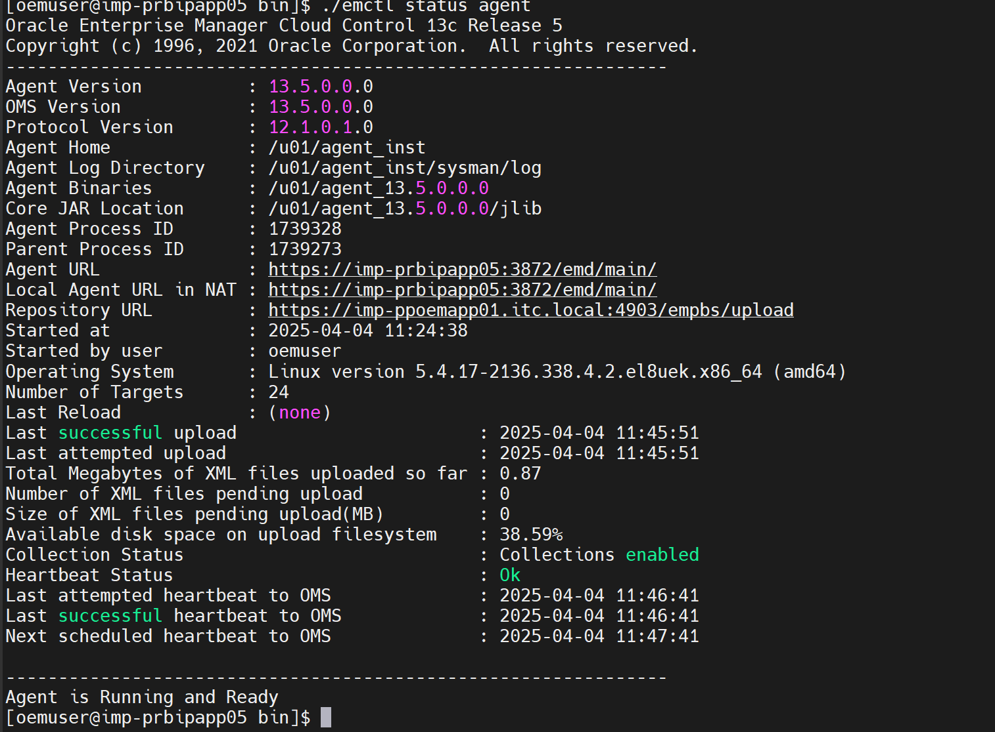
Scenario 2 (how to check agent availability in GUI)
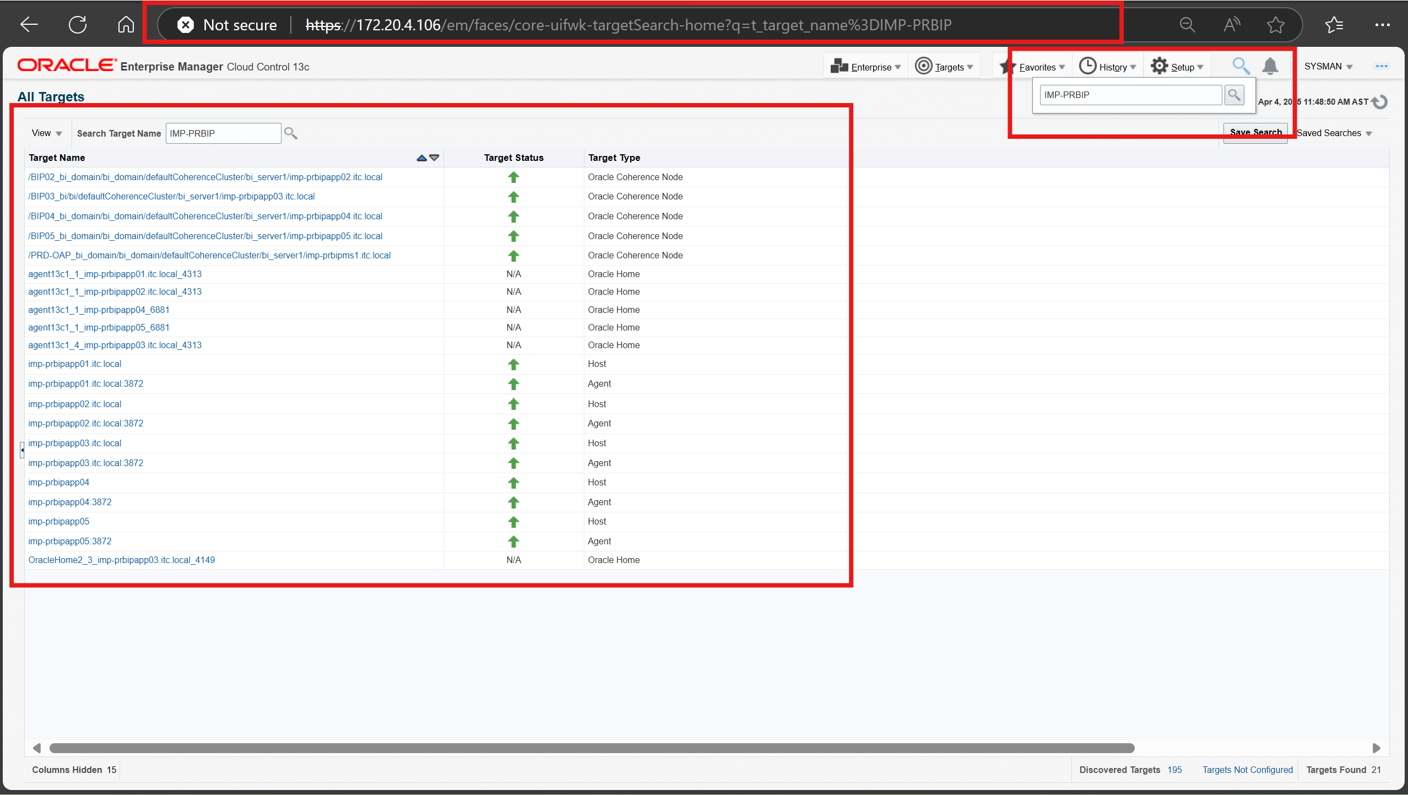
Scenario 3 (How to check OEM has application targets added )
Note:- only on premise application are visible with OEM. So, predominantly we have in OEM are Siebel, Middleware applications.
If we are requested to triage middleware apps please validate under this section of OEM
Targets à middleware
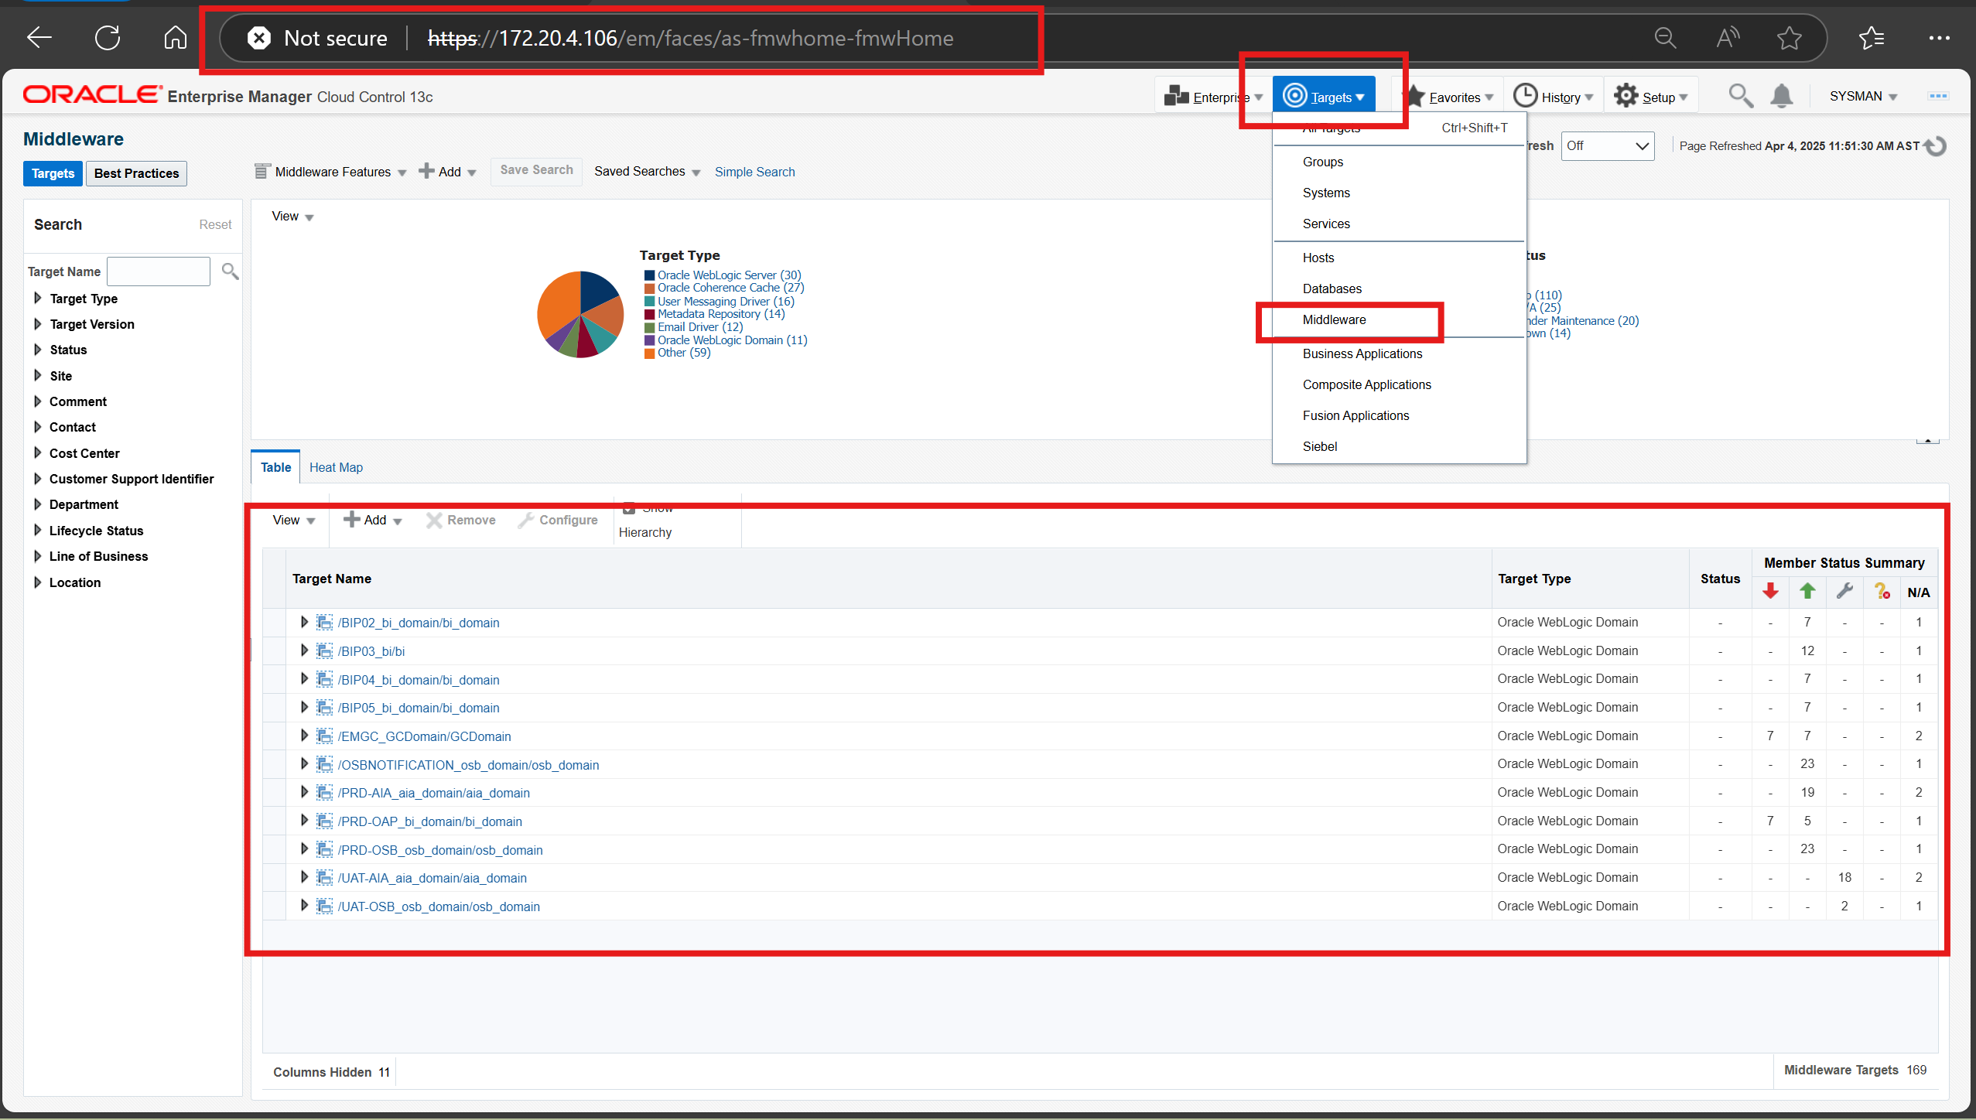
If requested to check Siebel, database. Under same same targets we need to choose the Siebel / DB as per need.
Please to note once we install a agent in new VM, we must ensure necessary targets discovery is done , which can be done through the below steps
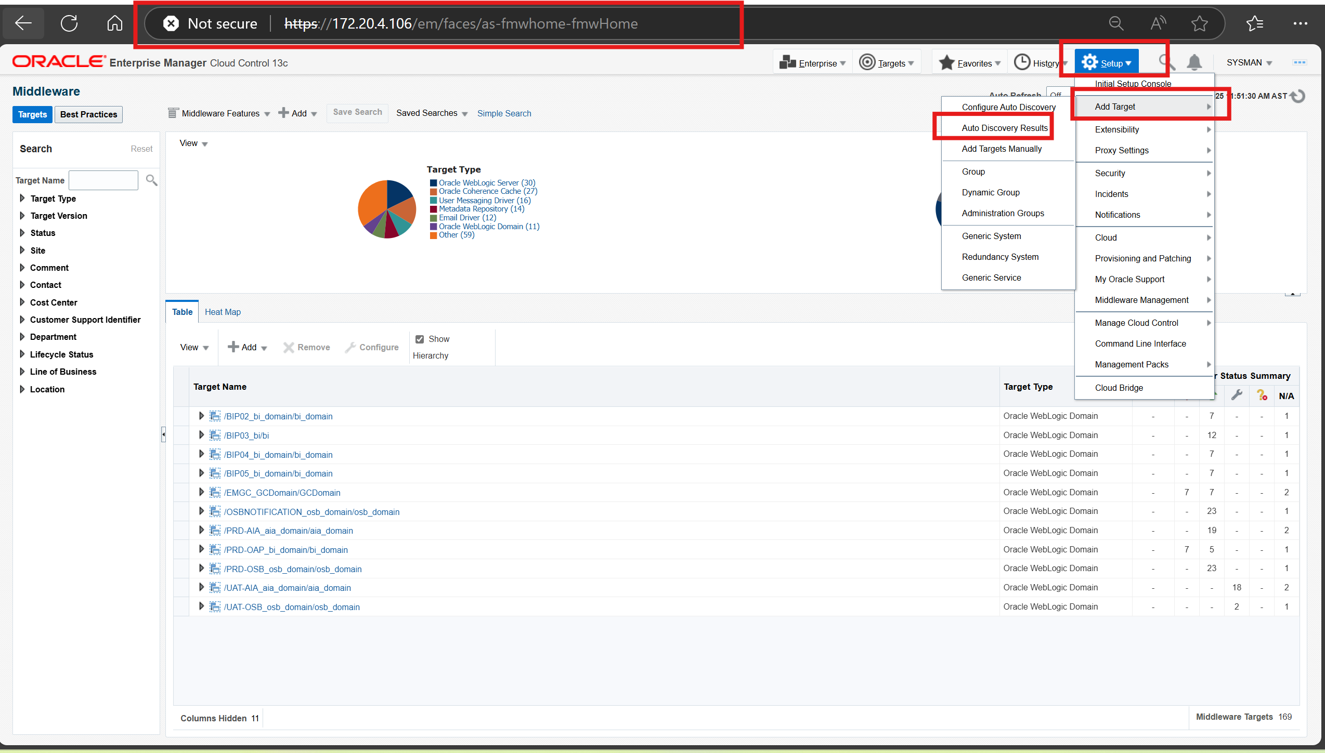
How to install a agent in a new VM :-

- Create oemuser with standard credentials (please discuss with Infra admin to know the latest oemuser credentials)
- Ensure necessary sudo privilege exists as other vm in OEM
- Create a /u01 directory with ownership as oemuser
- Ref :- Installing Oracle Management Agents 13c Release 1 for any installation related queries.

\

